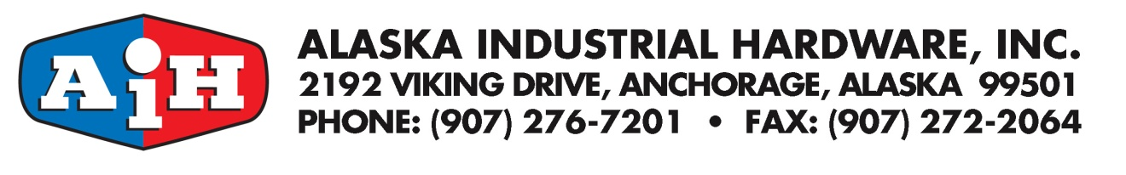

Online Account Administrator

Our new online account access gives you the time-saving ability to designate an online account Administrator.

Your online account Administrator can:

- Manage your Online Buyers
- Assign ship-to addresses
- View all orders and invoices

For more information about the responsibilities of the Administrator, go to Frequently Asked Questions at www.AIH.com/FAQ, AIH Customer Training booklet or contact websupport@aih.com.

Please complete the information below to assign your company administrator and either email credit@aih.com or fax to 907-279-1543.

Company name:

Account number:

Administrator Name: ______

Administrator Email:

By signing this form, you are authorizing Alaska Industrial Hardware to add the individual named above as your online account administrator. You also certify that you have the authority to do this on behalf of the above name company.

__________________________________ _____________________________
Signature of Authorized Representative Date

___________________________________ _____________________________
Print Name Title

If you have any questions, please email websupport@aih.com

